CO4_AT1_DATA INTERPRETATION

Name: Madhu Balan I
Reg no: 192321142
Course: Computer Vision

1. Real-Time Detection System
Method | Accuracy | Speed
Viola-Jones | 78% | Fast
YOLO | 92% | Moderate
Deep Learning | 95% | Slow

Question: Compare the three techniques and evaluate which method should be selected for a surveillance system operating under strict latency constraints while maintaining acceptable accuracy. Justify your decision considering deployment conditions.
Answer:
Viola-Jones is the fastest technique in the comparison, but its accuracy is only 78%. This means it can respond quickly, yet it is more likely to miss objects or produce incorrect detections. It may be acceptable for a simple, controlled environment with fixed camera positions, limited object types, and relatively good lighting. Its main advantage is that it can operate on modest hardware with low processing requirements.
YOLO achieves 92% accuracy with moderate speed. It provides a clear improvement of 14 percentage points over Viola-Jones while avoiding the slow response associated with the Deep Learning option. This makes YOLO a strong general-purpose solution for surveillance, particularly when the system must process video continuously and issue alerts without a noticeable delay.
Deep Learning gives the highest accuracy at 95%, but its slow speed may create delayed alerts, reduce the number of frames processed per second, and require more powerful hardware. It is more appropriate when the surveillance system can tolerate additional latency or when a missed detection would have serious consequences and the deployment has sufficient GPU resources.
For the stated requirement, YOLO should be selected. It provides the best compromise between accuracy and latency: its accuracy is close to Deep Learning, but its moderate speed is more suitable for real-time operation. If the latency requirement is exceptionally strict, Viola-Jones could be used as a lightweight first-stage detector, followed by a more accurate detector only when a possible object is found. This two-stage arrangement can reduce average processing cost while preserving better accuracy than Viola-Jones alone.
Overall, the final decision should depend on camera resolution, number of simultaneous camera feeds, available CPU/GPU resources, network conditions, and the cost of false alarms versus missed detections. Under ordinary real-time surveillance conditions, YOLO is the most defensible choice because it maintains acceptable accuracy without the slow response and higher computational demand of Deep Learning.
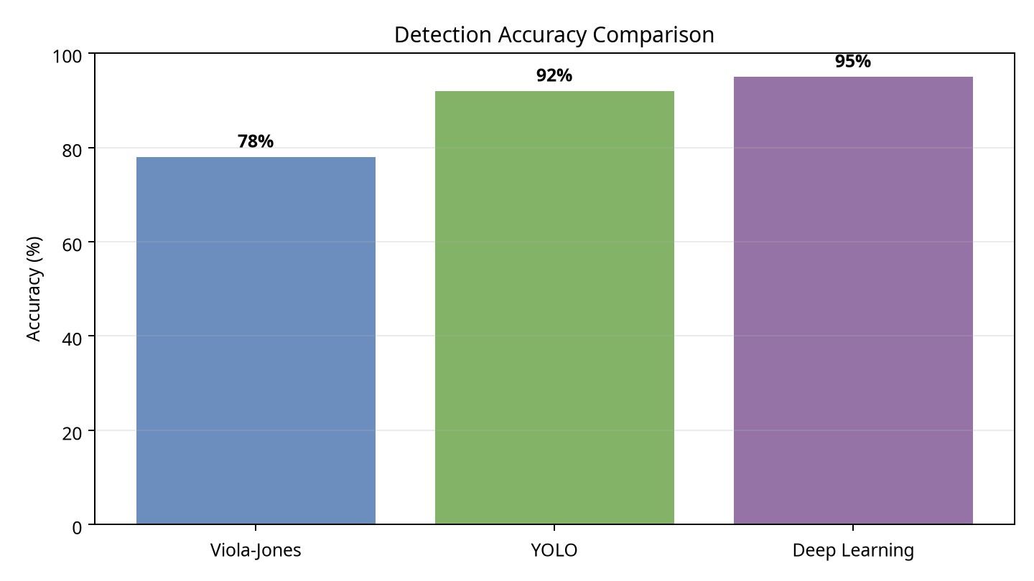
Figure 1. Accuracy comparison using the values supplied in Question 1.

2. Robust Object Detection
Method | Normal | Occlusion | Low Light
Viola-Jones | 80% | 60% | 55%
YOLO | 90% | 75% | 70%
Deep Learning | 95% | 85% | 80%

Question: Compare the robustness of the three methods under normal, occluded, and low-light conditions. Evaluate which method provides the best overall performance and discuss the trade-offs involved.
Answer:
Under normal conditions, Deep Learning performs best with 95%, followed by YOLO at 90% and Viola-Jones at 80%. The ranking remains the same under occlusion and low light. This consistency is important because a practical detection system must continue to work when objects are partly hidden, the scene changes, or the available illumination is poor.
Viola-Jones falls from 80% in normal conditions to 60% under occlusion and 55% in low light. Its reductions are 20 and 25 percentage points respectively, showing that it is sensitive to changes in object appearance and image quality. YOLO decreases from 90% to 75% under occlusion and 70% in low light, while Deep Learning decreases from 95% to 85% and 80%. Therefore, Deep Learning not only has the highest absolute accuracy but also retains the greatest accuracy when conditions become difficult.
The average accuracy across the three conditions is 65.0% for Viola-Jones, approximately 78.3% for YOLO, and approximately 86.7% for Deep Learning. On the supplied evidence, Deep Learning provides the best overall robustness. Its advantage is especially valuable in outdoor surveillance, crowded public areas, nighttime monitoring, and situations in which objects are frequently blocked by other people or vehicles.
The trade-off is deployment complexity. Viola-Jones is likely to be cheaper and faster, but its performance deteriorates sharply outside ideal conditions. YOLO provides a useful middle ground: it is more robust than Viola-Jones and may still be capable of real-time operation on suitable hardware. Deep Learning is the preferred method when reliability is the main objective, but it may require a GPU, greater memory, more energy, and additional model optimisation. Techniques such as data augmentation with shadows and occlusions, infrared cameras, image enhancement, and confidence calibration could further improve performance in difficult environments.
Consequently, Deep Learning is the best overall performer, YOLO is the best practical compromise for many real-time systems, and Viola-Jones is appropriate only when low cost and low computational demand outweigh the need for robust detection.
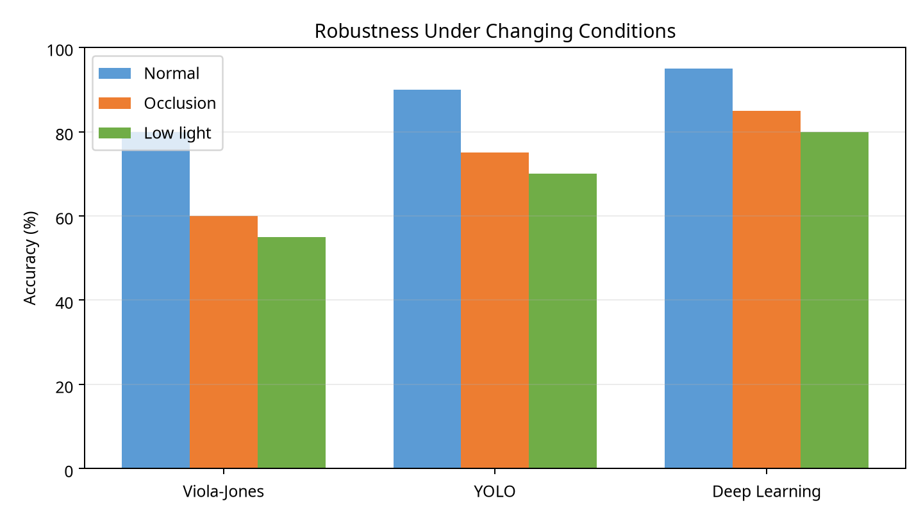
Figure 2. Performance of the three detection methods under normal, occluded, and low-light conditions.

3. Optical Flow Analysis
Available methods: Method A produces stable motion vectors but misses small motions. Method B detects fine motion but produces noisy vectors.
Question: Compare the two methods and evaluate which method is more suitable for motion tracking in dynamic scenes. Justify your answer based on accuracy, stability, noise sensitivity, and application requirements.
Answer:
Method A prioritises stability. Its motion vectors change smoothly and are less affected by random image noise, so it is easier to use when the objective is to estimate the general direction of movement or maintain a stable trajectory over time. However, because it misses small motions, it may fail to detect subtle gestures, small objects, slow movement, or motion occurring in only part of an object.
Method B prioritises sensitivity and fine-detail accuracy. It can identify smaller or more complex movements that Method A may ignore. This makes it valuable in dynamic scenes containing multiple moving objects, rapid changes, partial movement, or small actions. Its weakness is that the vectors are noisy, which can result in jitter, false motion, unstable trajectories, and incorrect tracking if the raw output is used without post-processing.
For dynamic-scene motion tracking, Method B is generally the more suitable choice when detecting fine motion is important. The noise problem can be reduced using spatial smoothing, temporal filtering, median filters, confidence thresholds, outlier removal, or robust estimation of the dominant motion. A tracker can also combine Method B with object detection and motion prediction so that isolated noisy vectors do not immediately cause an identity switch.
Method A should be selected when stability, low computational cost, and predictable output are more important than detecting every small movement. Examples include camera stabilisation, coarse scene-motion estimation, and applications in which noisy output would be more damaging than missed fine detail. Method B should be selected for gesture recognition, detailed activity analysis, sports monitoring, and surveillance where small movements may carry important information.
There is no universally superior method. The correct choice depends on the loss function of the application: if false motion and jitter are unacceptable, Method A may be safer; if missed motion is more serious than noise, Method B is preferable. For the question’s dynamic-scene tracking requirement, Method B with filtering and confidence control provides the stronger overall solution.

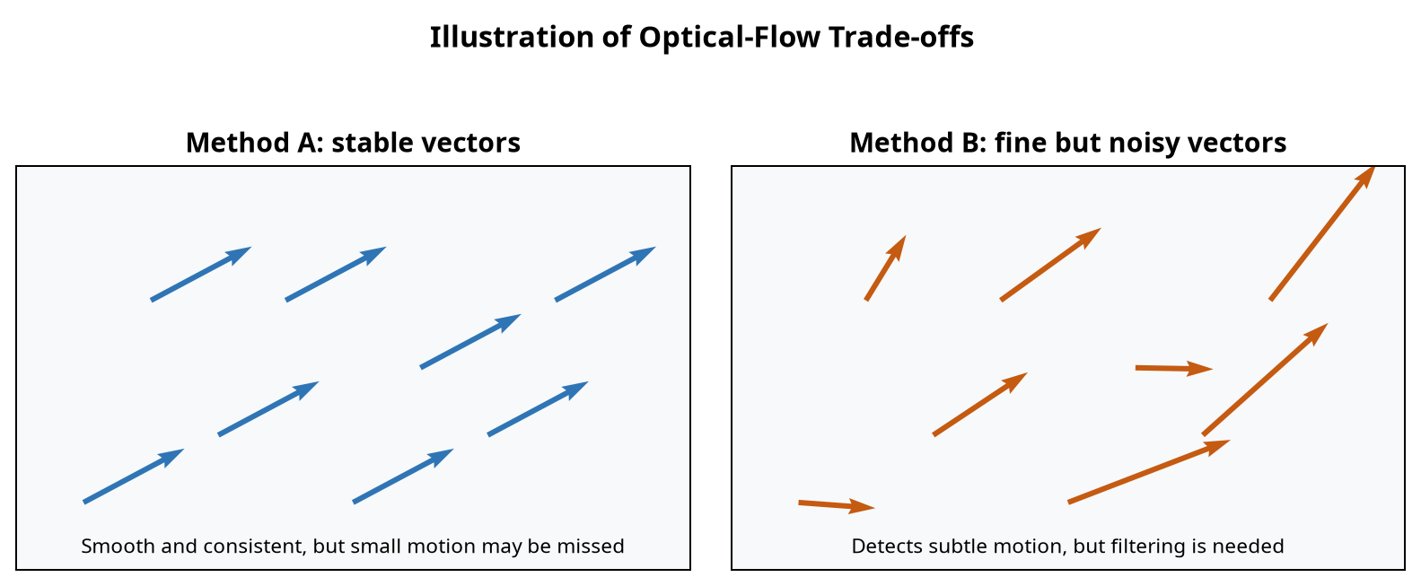
Figure 3. Illustrative comparison of stable motion vectors and fine but noisy motion vectors.

4. Model Generalization and Overfitting
Model | Training Accuracy | Testing Accuracy
A | 98% | 70%
B | 90% | 88%

Question: Compare the two models and evaluate which model is more reliable for real-world deployment. Explain the generalization ability and overfitting risk of each model and justify your selection.
Answer:
Model A achieves 98% training accuracy but only 70% testing accuracy. The difference between the two results is 28 percentage points. This large generalization gap indicates that Model A has fitted the training examples very closely, including patterns that may not be present in new data. Its high training score is therefore misleading: it does not translate into dependable performance outside the training set.
Model A has a high risk of overfitting. In a real deployment, the camera angle, lighting, object scale, background, and behaviour may differ from the training data. Because Model A performs poorly on the test set, it is likely to produce more false positives or false negatives when exposed to these variations. Possible remedies would include collecting more diverse training examples, applying data augmentation, using regularisation, simplifying the model, applying early stopping, and checking performance with cross-validation.
Model B achieves 90% training accuracy and 88% testing accuracy, giving a small 2-percentage-point gap. The closeness of its results suggests that the model has learned general patterns rather than memorising the training examples. Its testing accuracy is also high, so it combines strong performance with better generalization. This makes it more likely to remain dependable when deployed on unseen data.
Model B is the more reliable model for real-world deployment. In production, testing or validation performance is a better indicator of likely real-world behaviour than training accuracy. Model A may appear stronger in a training report, but Model B has the better balance of accuracy, stability, and generalization. A final deployment decision should still include testing on representative field data, monitoring after release, and checking for data drift, but the supplied results strongly support Model B.
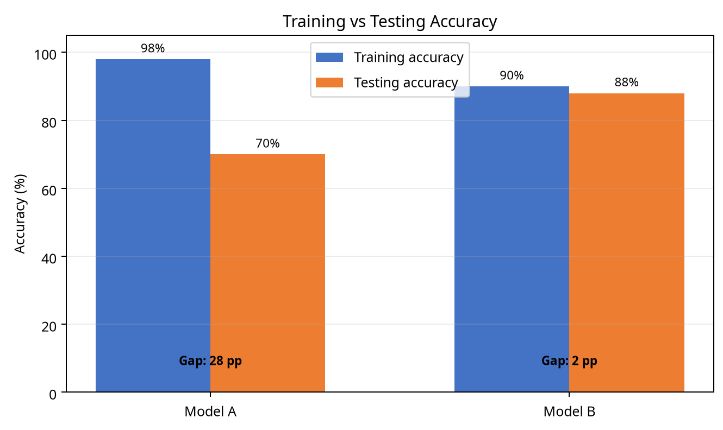
Figure 4. The small testing gap of Model B indicates better generalization than Model A.

5. System Performance under Constraints
Model | Accuracy | Latency | Cost
A | 88% | 50 ms | Low
B | 92% | 80 ms | Moderate
C | 95% | 120 ms | High

Question: Compare the three models and evaluate which model provides the best balance between accuracy, latency, and cost for a real-time application. Justify your choice considering practical deployment constraints.
Answer:
Model A is the fastest and least expensive option. Its 50 ms latency supports rapid responses and high throughput, and its low cost makes it attractive for edge devices or systems with a large number of cameras. However, its 88% accuracy is the lowest of the three, so the application may experience more missed detections or false alarms.
Model B increases accuracy to 92% and has a latency of 80 ms. The 4-percentage-point accuracy improvement over Model A may significantly reduce errors, while an 80 ms response remains suitable for many real-time applications. Its moderate cost is also more manageable than Model C’s high cost. Model C has the highest accuracy at 95%, but its 120 ms latency and high cost may reduce responsiveness, increase hardware requirements, and make large-scale deployment difficult.
Model B provides the best overall balance. Compared with Model A, it gains 4 percentage points of accuracy for an additional 30 ms of latency and a moderate cost increase. Compared with Model C, it gives up only 3 percentage points of accuracy but saves 40 ms of latency and avoids the highest cost. This is a relatively small accuracy sacrifice in exchange for a meaningful improvement in responsiveness and affordability.
The deployment decision should consider the maximum acceptable response time, available hardware, energy consumption, number of simultaneous streams, and the consequences of incorrect decisions. Model A is appropriate when 50 ms is a strict deadline or when the system must run on inexpensive hardware. Model C is justified when accuracy is critical, the number of streams is small, and the budget allows high-performance hardware. For a normal real-time system that must balance quality, speed, and cost, Model B is the recommended selection.
In conclusion, Model B is the most practical choice because it avoids the low accuracy of Model A and the excessive latency and cost of Model C. It is not the best on any single measure, but it is the strongest compromise across all three deployment constraints.
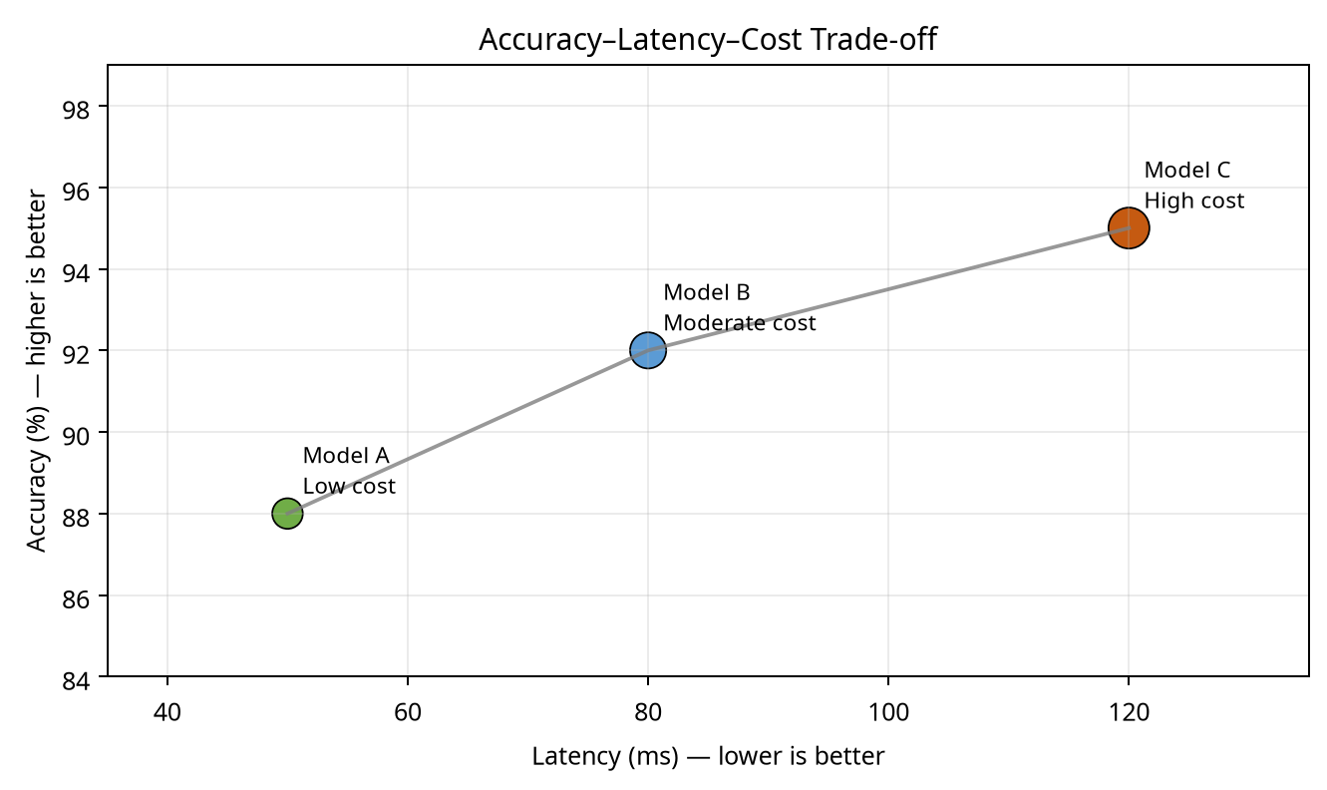
Figure 5. Accuracy, latency, and cost trade-offs for the three models in Question 5.
Conclusion
Across the five scenarios, the results show that selecting a computer-vision method requires more than choosing the highest accuracy. Latency, robustness, generalization, noise sensitivity, hardware, cost, and the consequences of errors must all be considered. YOLO is the strongest latency–accuracy compromise in Question 1, Deep Learning is the most robust method in Question 2, Method B is preferred for detailed dynamic motion when filtering is applied, Model B generalizes best in Question 4, and Model B again provides the most balanced deployment option in Question 5.

